BECE206P Analog Circuits Lab Experiment 6

Name: ANKIT NEGI

Reg. No.: 22BEC1117

**Monostable Multi-Vibrator**

# AIM: To design and verify a Monostable Multi-Vibrator circuit using IC-555.

# SOFTWARE REQUIRED: LTspice

**CIRCUIT DIAGRAM:**

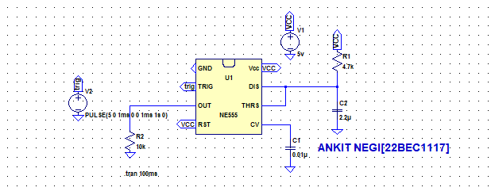

# PROCEDURE:

1. Create the circuit for the Monostable Multi-Vibrator circuit by referring to the circuit diagram.
2. Input all the component values by right clicking on the components.
3. Right click on the V1 voltage and choose the “Pulse” option and input the required values.

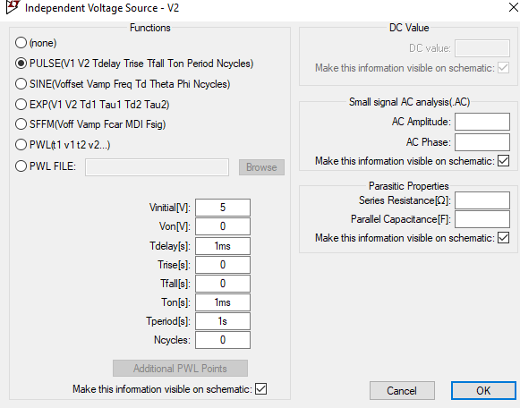

1. Make sure to label the trigger and Vcc properly and ground all the circuits.
2. Simulate the circuit using Transient analysis with the required values to get the output and verify the results.

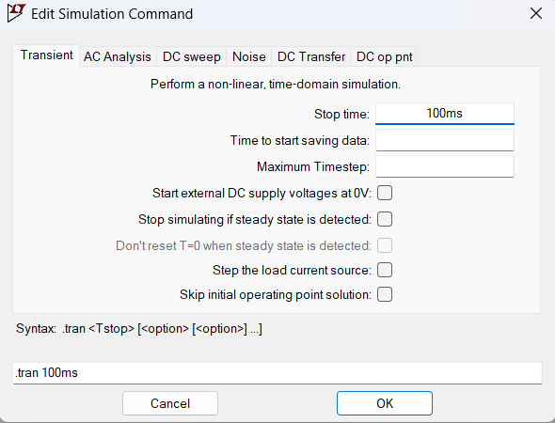

1. Use “add plot panes” in the output window to get the required transient analysis graph output.

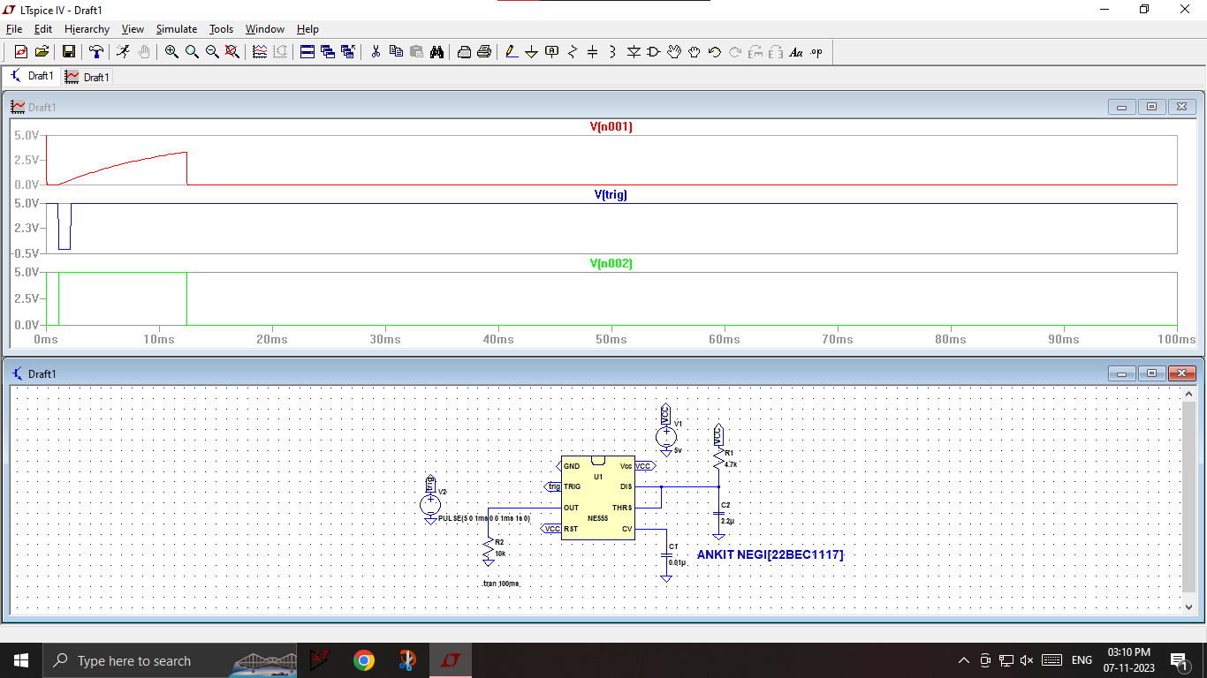

**OBSERVATION:**

It can be observed that the experiment highlights the functionality and predictable response of the Monostable Multi-Vibrator in generating a single output pulse in response to input triggers.

**RESULTS:**

1. In a simulation experiment of a monostable multivibrator, the observed results indicate that the circuit exhibits a stable state with a single output pulse triggered by an external input. The simulation confirms the expected behavior of a monostable multivibrator, where the circuit remains in its quasi-stable state until an external stimulus triggers a transient response, leading to a well-defined output pulse. The experiment provides valuable insights into the dynamic characteristics of the monostable multivibrator, aiding in the understanding and analysis of its applications in various electronic systems.
2. Upon receiving a high trigger signal, the Monostable Mutli-Vibrator circuit resets, establishing the output in a low state (Q=0, Q’=1). Upon receiving a low trigger signal, the Monostable Mutli-Vibrator circuit sets, resulting in a high output (Q=1, Q’=0).